01-Intelligence Lexicon and Definitions

# 

# Introduction

|  |
| --- |
| “By ‘intelligence’ we mean every sort of information about the enemy and his  country—the basis, in short, of our own plans and operations.”  Carl von Clausewitz  On War , 1832 |

A. Information is of greatest value when it contributes to the commander’s decision-making process by providing reasoned insight into future conditions or situations. This may occur as a result of its association with other information from the commander’s experience. Raw data by itself has relatively limited utility. However, when data is collected from a sensor and processed into an intelligible form, it becomes information and gains greater utility. Information on its own may be of utility to the commander, but when related to other information about the OE and considered in the light of past experience, it gives rise to a new understanding of the information, which may be termed “intelligence.” The foundation of the process that produces intelligence is built by analysts relating or comparing information against other information or a database, and drawing conclusions. The relationship between data, information, and intelligence is graphically depicted in Figure I-1. Ultimately, intelligence has two critical features that distinguish it from information. Intelligence allows anticipation or prediction of future situations and circumstances, and it informs decisions by lluminating the differences in available courses of action (COAs).

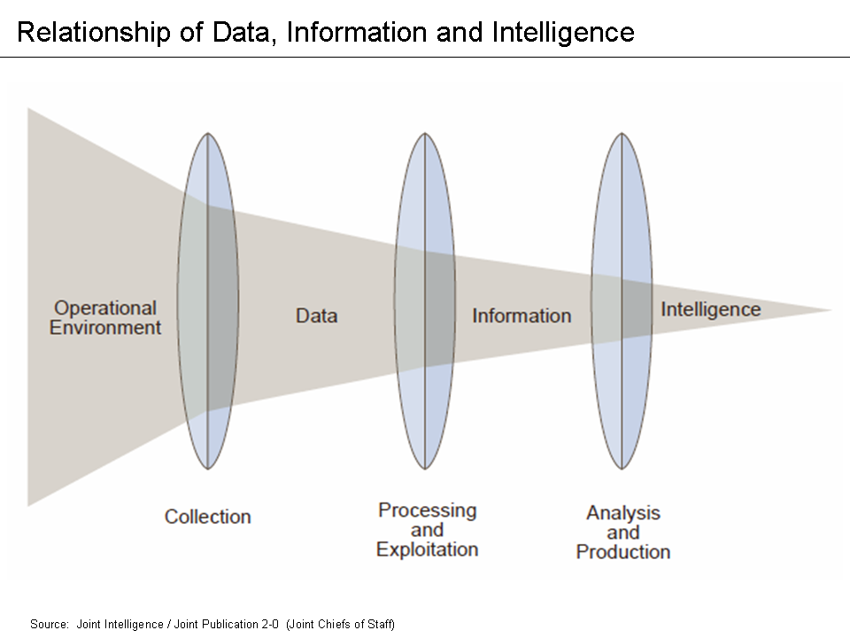

B. Intelligence provides the commander a variety of assessments and estimates that facilitate understanding the OE. Assessments are situational, for example some assessments will be threat-based providing an analysis of threat capabilities and intentions; others are population-based, providing the commander an analysis of sociocultural factors. With predictive, accurate, and relevant intelligence estimates, commanders gain an advantage in the OE by understanding an adversary’s decision-making cycle, and possibly predicting and countering adversarial operations. Regardless of the situation, intelligence assessments and estimates enable commanders to formulate plans and make better decisions based on this knowledge. Thus, predictive, accurate, and relevant intelligence can mitigate the risks inherent in military operations and increase the likelihood of success.

C. Intelligence is not an exact science; intelligence analysts will have some uncertainty as they assess the OE, as should the commander and staff as they plan and execute operations. Intelligence, as the synthesis of quantitative analysis and qualitative judgment is subject to competing interpretation. It is therefore important that intelligence analysts communicate the degree of confidence they have in their analytic conclusions. Such communication of analytic confidence helps intelligence consumers in deciding how much weight to place on intelligence assessments when making a decision. One methodology intelligence personnel may use to assign a confidence level to their analytic conclusions or intelligence assessments is discussed in Appendix A, “Intelligence Confidence Levels in Analytic Judgments.”

D. Intelligence includes the organizations, capabilities, and processes involved in the collection, processing, exploitation, analysis, and dissemination of information or finished intelligence. Intelligence, however, is not an end in itself. To increase the operational relevance of intelligence, intelligence planners and managers should anticipate consumer needs. Thus, an examination of whether intelligence is effective or influential not only depends on the intelligence organizations, processes, and products, but must also examine users’ intelligence needs. Explicit user requirements, identified and properly communicated to intelligence organizations by intelligence planners, initiate the appropriate intelligence activities. Intelligence products provide users with the information that has been collected and analyzed based on their requirements. It is important to remember that because the OE is dynamic, intelligence is a continuous activity.

# Roles And Responsibilities of Intelligence

The primary role of joint intelligence is to provide information and assessments to facilitate mission accomplishment. This role is supported by a series of specific responsibilities to guide the intelligence directorate of a joint staff (J-2) and supporting organizations (see Figure I-2).

*For further information, see Joint Publication (JP) 2-01.3, Joint Intelligence Preparation of the Operational Environment.*

**A. Inform the Commander.** Intelligence directly supports the joint force commander (JFC) in planning, executing, and assessing the impact of those operations. The J-2 analyzes the adversary and other relevant aspects of the OE, and produces assessments on a continuing basis to support the commander in creating and/or exploiting opportunities to accomplish friendly force objectives. For example, to maintain the initiative, the JFC will seek to understand and potentially influence the adversary’s decision-making process (e.g., the JFC will seek new and accurate intelligence that will enable friendly forces to take effective action faster than the adversary). The J-2 should assess the characteristics of the adversary’s decision-making process and identify weaknesses that may be exploited. The J-2 should disseminate intelligence in a timely manner to the JFC, staff, and components.

**B. Describe the OE.** Present the OE as a confluence of the conditions, circumstances, and influences that affect the employment of friendly and adversary forces. Describing this OE to the commander and staff affects the commander’s COA assessment, as well as future operations.

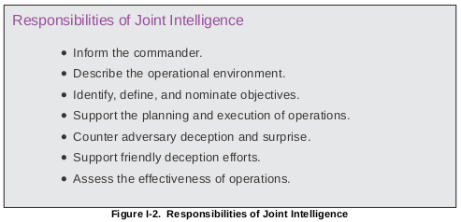

**C. Identify, Define, and Nominate Objectives.** All aspects of military planning are

dependent on the determination of clearly defined, achievable, and measurable objectives.

When identifying and nominating objectives, the J-2 should understand the command’s

responsibilities; the JFC’s mission and intent; means available, including host nation and

multinational forces, interagency partners, nongovernmental organizations (NGOs), and

intergovernmental organizations (IGOs); the adversary; weather; and characteristics of the

operational area. Intelligence should increase the commander’s understanding of the threat

and adversary’s probable intentions, end states, objectives, most likely and most dangerous

COAs, strengths, and critical capabilities. This allows the J-2 to recommend objectives,

requirements, and centers of gravity (COGs). Once these objectives are approved by the

commander, the J-2 must continuously review them with respect to the adversary and the

changing situation to determine whether they remain relevant to the commander’s intent.

**D. Support the Planning and Execution of Operations.** Commanders and staffs at all

levels require intelligence to plan, direct, conduct, and assess operations. This intelligence is

crucial to commanders, staffs, and components in identifying and selecting specific

objectives and targets, associating them with desired effects, and determining the means to

accomplish the JFC’s overall mission. The J-2 supports the execution of the plan with the

strategic, operational, and tactical intelligence needed to sustain the operation.

**E. Counter Adversary Deception and Surprise.** Joint force vulnerability to threat

denial and deception will be determined, in large part, by the threat efforts to deny and

deceive collection efforts. Intelligence analysts should remain sensitive to the possibility that

they are being deceived and should consider all possible adversary capabilities and

intentions. Similarly, analytical approaches that emphasize anomalies characterized by a

lack of activity (e.g., absence of seasonal training, important persons missing from

ceremonial events) are particularly valuable. To counter adversary deception efforts,

intelligence analysts must confirm their analysis using multiple and proven analytical

methods and processes (e.g., use of red teams, devil’s advocates, alternative hypotheses).

**F. Support Friendly Deception Efforts.** Altering the perception of an adversary—to

mislead or delude—helps achieve security and surprise. Intelligence and counterintelligence

(CI) support effective friendly information operations (IO) through sociocultural analysis

(SCA) of adversary leadership characteristics. The J-2 also assesses how the adversary is

reacting to the friendly deception effort. Identifying deception objectives to complement

operational objectives should be an interactive process, which is aided by the use of a red

team or red cell.

*For further information, see JP 3-13, Information Operations.*

**G. Assess the Effectiveness of Operations.** Intelligence helps evaluate military

operations by objectively assessing their impact on the adversary and other relevant aspects

of the OE with respect to the JFC’s intent and objectives. Intelligence should assist JFCs in

determining if operations are producing desired or undesired effects, when objectives have

been attained, and when unforeseen opportunities can be exploited or require a change in

planned operations to respond to adversary (enemy) actions.

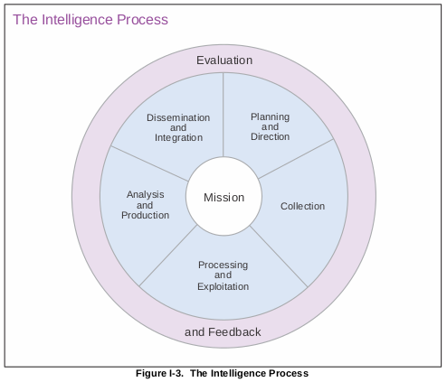

## Levels of intelligence

Intelligence operations are carried out throughout the hierarchy of political and military activity.

### **Strategic intelligence**

(1) National strategic intelligence is produced for the President, the National Security Council, Congress, SecDef, senior military leaders, CCDRs, and other US Government departments and agencies. It is used to develop national strategy and policy, monitor the international and global situation, prepare military plans, determine major weapon systems and force structure requirements, and conduct strategic operations. Strategic intelligence operations also produce the intelligence required by CCDRs to prepare strategic estimates, strategies, and plans to accomplish missions assigned by higher authorities. In addition to this focus primarily on the military instrument of national power, strategic intelligence also allows for national leadership to determine potential options using the nonmilitary instruments of national power (diplomatic, informational, and economic) based on estimated opposing force or adversary reaction to US actions.

(2) Theater strategic intelligence supports joint operations across the range of military operations, assesses the current situation, and estimates future capabilities and intentions of adversaries that could affect the national security and US or allied interests. Theater strategic intelligence includes determining when, where, and in what strength the adversary will stage and conduct theater level campaigns and strategic unified operations.

### **Operational intelligence**

(1) Operational intelligence is primarily used by CCDRs and subordinate JFCs and their component commanders. Operational intelligence focuses on answering the commander’s PIRs, assessing the effectiveness of operations, maintaining situational awareness of adversary military disposition, capabilities, and intentions, and other relevant aspects of the OE. perational intelligence helps commanders keep abreast of events within I-24 JP 2-0The Nature of ntelligence their area of interest (AOI) and helps them determine when, where, and in what strength the adversary might stage and conduct campaigns and major operations.

(2) Operational intelligence also includes monitoring terrorist incidents and natural or man-made disasters and catastrophes. During counterinsurgency and counterterrorism operations, operational intelligence is increasingly concerned with stability operations and has a greater focus on PMESII factors. It also assists commanders in assessing and evaluating actions and possible implications associated with noncombat operations such as foreign humanitarian assistance

### **Tactical intelligence**

(1) Tactical intelligence is used by commanders, planners, and operators for planning and conducting battles, engagements, and special missions. Relevant, accurate, and timely tactical intelligence allows tactical units to achieve positional and informational advantage over their adversaries. Precise threat location, tracking, and target capabilities and status, in particular, are essential for success during actual mission execution. In addition, a key element of tactical intelligence is post-strike combat assessment, which is used by commanders and planners to determine the need to dynamically retask assets to restrike identified targets.

(2) Tactical intelligence addresses the threat across the range of military operations. Tactical intelligence operations identify and assess the adversary’s capabilities, intentions, and vulnerabilities, as well as describe the physical environment. Tactical intelligence seeks

to identify when, where, and in what strength the adversary will conduct tactical level operations. During counterinsurgency and counterterrorism operations, tactical intelligence is increasingly focused on identifying threats to stability operations. Together with CI, tactical intelligence will provide the commander with information on the imminent threats to the force from terrorists, saboteurs, insurgents and their networks, and foreign intelligence collection. The physical identification of the adversary and their operational networks allow for enhanced situational awareness, targeting, and watchlisting to track, hinder, or prevent insurgent movements within the region, nation, or international levels.